Graph Coloring and Chromatic Number
- Graph coloring is a fundamental concept in graph theory where colors are assigned to the vertices of a graph such that no two adjacent vertices share the same color.
- This technique is widely known as the vertex coloring problem.
- When this coloring is achieved using no more than m distinct colors, it is referred to as m-coloring.

Chromatic Number
- The chromatic number of a graph represents the smallest number of colors required to color its vertices without any two connected vertices having the same color.
- For instance, consider a graph that can be efficiently colored using just two colors—this implies its chromatic number is 2.
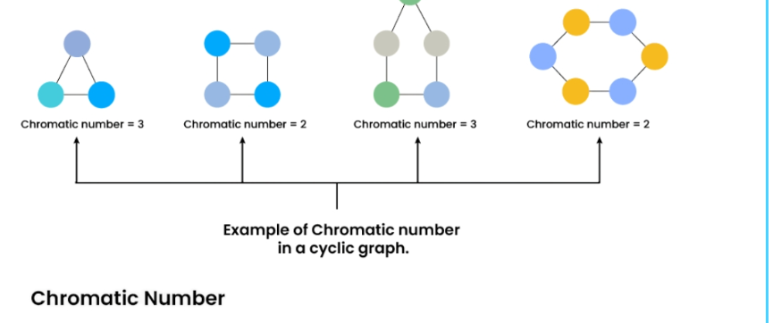
Details:

What is Chromatic Number?
The chromatic number of a graph G, denoted as χ(G), is the minimum number of colors required to color the vertices of a graph G in such a way that no two adjacent vertices share the same color. Formally, it is the smallest positive integer k for which there exists a proper vertex coloring with k colors.
- The chromatic number is an essential parameter that captures the inherent colorability of a graph.
- It provides insights into the structural properties and relationships within the graph.
Vertex Coloring:
- A vertex coloring of a graph assigns colors to its vertices in a way that no two adjacent vertices have the same color.
- Proper vertex coloring ensures that adjacent vertices have distinct colors

Chromatic Number of Cyclic Graph:
A graph is known as a cycle graph if it contains ‘n’ edges and ‘n’ vertices (n >= 3), which form a cycle of length ‘n’. The chromatic number in a cycle graph depends upon the parity of cycle length:
Case 1 (Odd length cycle): χ(G) = 3.
Case 2(Even length cycle): χ(G) = 2.

Chromatic Number of Complete Graph:
The chromatic number of a complete graph is equal to the number of vertices in the graph.

Chromatic Number of Bipartite Graph:
Non-empty bipartite graphs have a chromatic number of 2.
since the two parts are each independent sets and can be colored with a single color. Conversely, if a graph can be 2-colored, it is bipartite, since all edges connect vertices of different colors

Chromatic Number of Star Graph:
The chromatic number of a star graph is 2.

Chromatic Number of Wheel Graph with more than 3 Vertices
The chromatic number of a wheel graph is 3 if the number of vertices is even, and 4 if the number of vertices is odd.

Chromatic Number of Planar Graph:
A Planar Graph is a graph that can be drawn in a plane such that none of its edges cross each other.
χ(Planar Graph) <= 4
χ(Trees) = 2.

